A15 Amy Lawrence

Unit 5: About Health, Food and Fitness
My family is very healthy, and I can prove it. Health and well-being, mind and body are very important to my mother. She says she leaves the wealth up to dad. She doesn’t mind him being a workaholic, but she wants him to be a healthy one. We are healthy because of our mindset, diet, and exercise.
First, both my parents strongly believe that happiness is the key to health. The body follows the mind. Every morning my mom wakes us up by yelling, “Is everybody a happy camper today!” Too funny. She watches a lot of the medical shows on TV that talk about health problems. She thinks that stress is bad, so she never pushes us too much about our grades. She’s big into preventative measures, like exercise. Healthy habits that prevent sickness are better than medicine to cure. And my father’s motto is: “Happy wife, happy life.”
Second, my mother thinks that a good diet is the key to good health. She uses all fresh ingredients when she cooks, and she never lets us eat processed food that comes in a bag, like ramen or chips. She spends a lot of time cooking, but she calls it a labor of love. She knows which restaurants in the area have the healthiest food, and we get food delivered about once a week. And every weekend we go to a buffet or restaurant that has a good salad buffet. My father likes Dominos best.
Finally, while my mom is into happiness and food, my dad is into exercise. He works hard and he plays hard. He goes to the health club on his way home from work and mainly does the Nordic track. He says he works off the stress of the day before coming home. Of course, he rewards the workout with a glass of wine after supper. He used to drink beer and soju, but now it’s red wine. My sister and I are pretty active. She likes jazzercise and yoga, and I play soccer and tennis. We take a big skiing vacation every year. We’re all fit.
Therefore, you can see that my family is happy and healthy. My mom is like a morale officer in the army, always making sure we’re feeling good. Her motto is: if you’re not in a good mood, stay in your room. She also makes sure we eat well. It’s like her second job. And my father thinks that exercise is key. Working out strenuously relieves a lot of stress. My motto is: happy, healthy parents = happy life. (429 words)

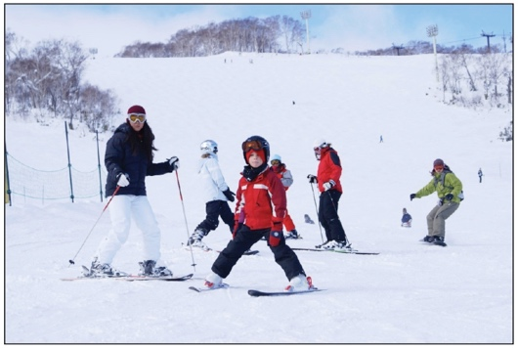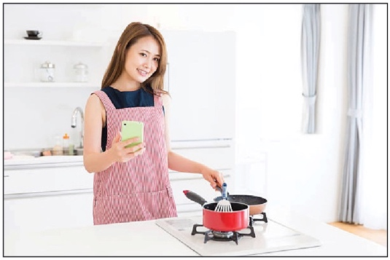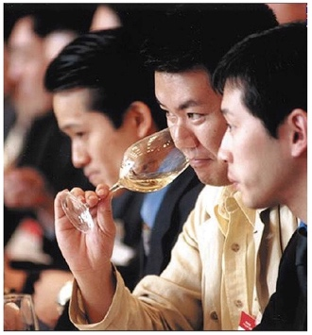
Dad sipping wine.
At home is wine glass
is much bigger.
Mom in cooking mode. Using the phone and Internet seems kind of
like cheating somehow
That’s me at Muju.
A well dressed wannabe.

VOCABULARY
happy | processed food | stress
preventative | labor of love | rewards
cure | morale officer | active
 | motto | strenuously

