5
What's your favorite sport?

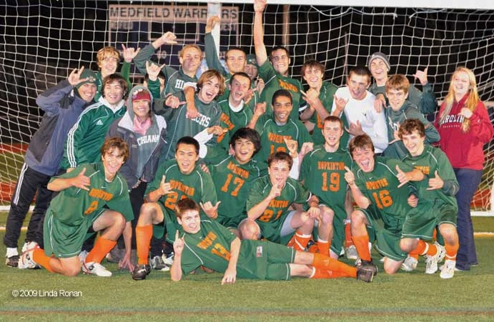
I know that I’ll never be very good but I love soccer, both to watch and play. I think soccer is about the best sport there is. I like it because it’s inexpensive to play, it’s a good exercise for your mind and body, and it’s great for companionship.
First, soccer is inexpensive. You don’t need a lot of fancy equipment like you do for skiing or rollerblading. All you need is a ball, and every school has a soccer field so it’s easy to find a place to play. I always play here at school. And you can play pretty much year round.
Second, soccer is a great exercise. It’s great for fitness and for coordination. With baseball there’s a lot of standing around. With soccer you can run as much or as little as you like. Soccer is also a pretty safe sport. In taekwondo and skiing, for example, you can get injured pretty easy.
Finally, soccer is good for companionship. It helps turn individuals into team players. I could never be a jogger because it’s too lonely. I like team sports. My best friends are all people I met on the soccer team. It’s like we’ll be friends for life.
I guess soccer is the most popular sport in the world, and I understand why. It’s inexpensive, so that anybody can play just about anywhere. It’s a great exercise for the body and the companionship is good for mental well being. (244)

Background sentence I know I’ll never be any good
Topic sentence I think soccer is the best sport

The A B C Specific examples
A inexpensive cheaper than skiing and rollerblading
B great exercise good for fitness and coordination
C companionship builds friendship and teamwork

