4
What's your favorite movie?

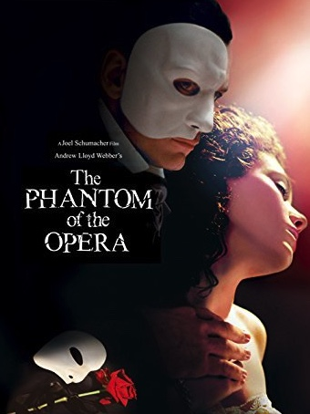
I love movies - all kinds of movies, every genre. Well, maybe not horror movies, such as the Curse of Dawn, that kill people. I usually watch romantic drama and action-adventure. My favorite movie is the Phantom of the Opera, it combines both romance and action. I love it because of the story, the acting, and the music.
First, the story is a love triangle. For example, the story takes place in Paris at the turn of the century, around 1860, at the world famous opera house. Raul and Christine are falling in love with each other. But the Phantom also loves her so he is jealous of them and he cries out. The scene was a bit of a tear jerker.
Second, the acting is another reason that I love Phantom of the Opera. Gerard Bulter, who plays the Phantom, and Emmy Rossum, who plays Christine, are both great. First of all, they did both acting and singing. I think it is difficult to do. Emmy Rosum was the leading lady in Tomorrow, but I didn’t know that she is a good singer.
Third, the original sound track is also fantastic. I bought the CD before I saw the movie. Phantom of the Opera is based on Opera. I had already read the book and seen the opera in London. I love it when they mix in old classics with new movies. I like the song ‘Music of the Night,’ which is sung by the Phantom. Sometimes I imagine playing their parts.
Usually, I do not like opera, but Phantom of the Opera was special. It breathes with life and passion. It is joyful and intense. The story, acting, and the music were awesome. This movie makes me want to go to an opera house and explore. (298 words)

Background sentence I love movies, all kinds of movies, every genre.
Topic sentence I love Phantom of the Opera because...

The A B C Specific examples
A the story Love story set in Paris around 1860
B the acting Gerard Butler and Emmy Rosum both act and sing
C the music I love 'Music of the Night'

