A12 Kim, Park lee

6 Festivals & Getting There

During the week, my transportation life is long. I live on the outskirts of town, and I have a three-hour commute each day. And every day it’s at rush hour. My first class is at 9:00 and my last class is at 5:00. I take the subway, line number four line and luckily I don’t have any transfers. I live near the end of the line so I can usually get a seat in the morning. On the weekends I usually hang out in my neighborhood. For any other travel, I take a city bus. It’s much less stressful than the subway, and I can always sit down.
The good news about living on the outskirts is that it’s easy to get out of town on the weekends. However, sometimes coming back to town on Sunday evening, the traffic is bumper to bumper. My father is a country boy at heart, and he likes to get out of town every chance he gets. We have a big SUV, so it’s pretty convenient to travel. And he always takes the long, scenic route. We get lost every now and then, but my father says that’s part of the adventure! Actually, I think he pretends to be lost sometimes. I mean, he’s got a GPS in the car and on his phone. Anyway. He’s an action addict, adrenaline junkie. He likes the great outdoors. He likes roughing it, and mom goes along, reluctantly. My parents really look forward to the weekends. My father likes to plan things down to the last detail, but my mom is more spontaneous. She tells him “We’re going to the woods. The bears don’t care, let’s go!” I usually ride shotgun and he makes me the navigator. I watch the GPS and tell him when and where to turn. When it’s peak season or holidays, he likes to leave at the crack of dawn to beat the traffic. He likes to travel light, so if we need anything we just pick it up on the way. My parents both work very hard during the week, so I think getting away on the weekends is their way of making sure our family gets enough quality time. (368words)

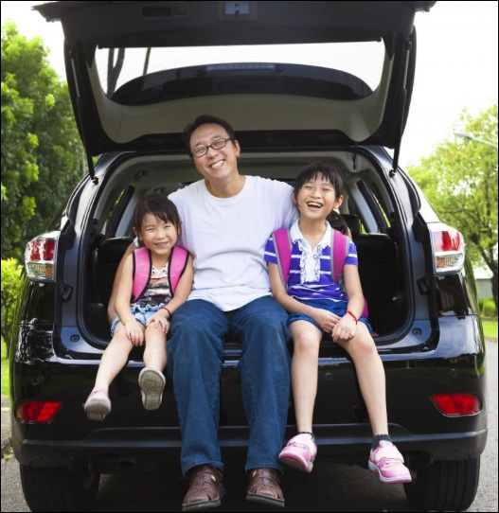
- outskirts of town
- commute
- rush hour
- transfers
- end of the line
- less stressful
- outskirts
- bumper to bumper
- country boy
- at heart
- SUV
- convenient
- scenic route
- get lost
- action addict
- adrenaline junkie
- roughing it
- look forward to
- spontaneous
- ride shotgun
Friday!
- navigator
- crack of dawn
- peak season
- travel light
- quality time

