A12 Kim, Park lee

5 Health & Happiness

I am generally pretty healthy. I broke my leg when I was seven. I was jumping into the pool, but I missed the pool. Actually, I am pretty sure that I was pushed, but I have no proof. Anyway. I hurt pretty bad for a while and my leg was black and blue by the time we got to the hospital. Then they put a cast on it, and it was OK. I wore the cast for about two months. All my friends wrote their name on my cast, so that was pretty cool. Otherwise, I rarely catch a cold and when I do it is not too severe.
My older sister has sinus problems with pollen every spring. Her eyes water, and it looks like she’s upset about her boyfriend, but she says it’s just her sinuses. She wore braces in middle school and she hated that, but she loves her teeth now. She wears glasses and contacts, and she’ll get LASIK surgery this winter. She can’t wait. Her body had an allergic reaction to contacts, so she does not wear them anymore.
Good genes run in our family. We are all tall, fit, and healthy, and my parents think that health and well-being are important. My mom says “Unhealthy students cannot study for hours and hours so you guys stay healthy!” She and dad belong to a health club and go three times a week. Dad goes swimming, and mom goes to the stretching class. They are both in pretty good shape and they signed up to run a half-marathon this winter. My two sisters and I are going to dress up as Marvel Super heroes and cheer them on near the finish line. (286 words)

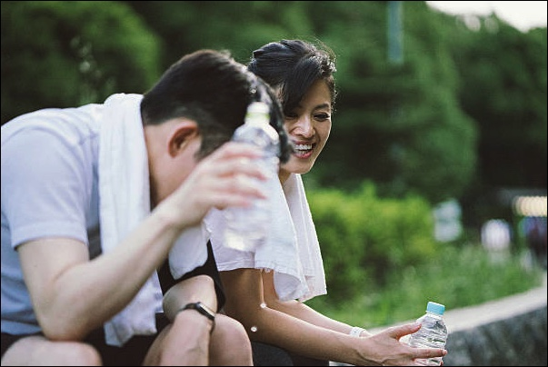
Vocabulary
- black and blue
- cast
- catch a cold
- severe
- sinus, sinuses
- pollen
- contacts
- LASIK
My parents practicing or the half marathon.
- genes
- run in our family
- good shape
- half-marathon

