A12 Kim, Park lee

4 Shopping & Special Days

My last birthday was awesome. My friends took me out (American style, they paid) to Outback. Also, my father always adds a $100 bill to my allowance on my birthday. So, my friends treated me to Outback, and I treated them to a sports bar after. Ireland was playing Scotland and they absolutely could not understand the announcers’ accents. My English professor is from Scotland so I was able to translate. Good times. I kept the receipts and framed them, and put them on my wall as souvenirs. We took a lot of selfies, and some are on my wall. I put a bunch of photos on my Facebook page. From the photos you can watch the progression of our drinking. Too funny. My mother took me shopping for my birthday, which is unusual because normally she’s a bargain shopper and shops only on sale days. She said I need some good casual clothes for school, and she knows clothes. She bought me some dressy jeans and polo shirts. I begged a little, and she got me some Nike tennis shoes. Nike has such a wide variety of shoes, it was hard to choose. She also bought me some wireless earphones, which are now a necessity rather than an accessory. My mom is into one-stop shopping, so that was convenient. All in all, it was a great birthday. Great parents, good friends, and new clothes. All I need now is a girlfriend. And an iPhone 12 to call her with. (250 words)

Vocabulary
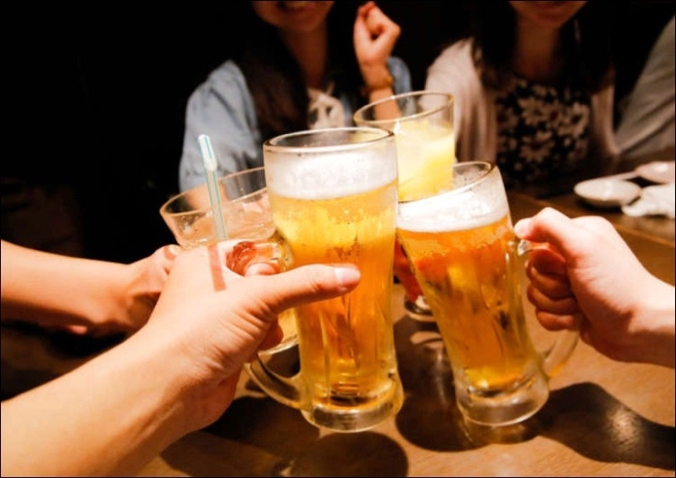
- allowance
- treated
- selfies
- progression
- bargain shopper
- casual clothes
- dressy jeans
- wide variety
- necessity
- accessory
Outback. The waitress was not the best photographer.
- one-stop shopping
- convenient

