Unit 4: What’s your favorite movie?

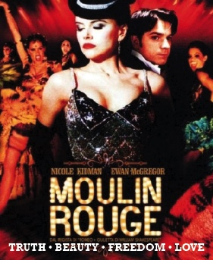
My favorite movie is Moulin Rouge. The movie is about truth, beauty, art and love. But mainly it’s about love! I’m an artist, so I can understand that line. Artists must suffer for their art. They must have passion. The movie is intense, joyful, and it celebrates life and passion. Moulin Rouge is my favorite movie because of the story, the acting, and the music. This movie is art. This movie is passion.
The story takes place in Paris at the turn of the century, around 1900, at the world famous nightclub and cabaret, the Moulin Rouge. A middle class English youth goes to Paris to become a writer, to write about truth, beauty, art and love. The only problem is, he has never been in love! That is solved as soon as he sees the beautiful show girl, Sateen, played by Nicole Kidman. It is love at first sight for him. Then you have a case of mistaken identity (she thinks he is a rich duke), and then a case of unrequited love (boy meets girl, boy loses girl, boy gets girl). He writes a play for Sateen that a rich duke pays for. Who will Sateen go with: the rich duke or the poor artist? Of course she chooses the poor artist! But, she gets sick and dies. The artist learns of love, and his love-filled heart is broken. He will live and love again, but no one will ever match Sateen. She died young and beautiful and passionate, he will always remember her that way. In his heart, she can never grow old.

The acting is another reason that I love Moulin Rouge. Ewan McGregor and Nicole Kidman are great. I cannot imagine anyone else playing their parts. The master of ceremonies, the midget Toulouse Lautrec, and the intense Spanish lover were all great. I think it would be very hard to act in a movie like that. It is not a realistic drama, and not a comedy, so finding the right mood to act for the character must be very difficult. I think this was Ewan’s first musical and first comedy. When he made that movie, he was about the hottest leading man in Hollywood. In addition to Moulin Rouge, he was in the final Star Wars, and The Island. Nicole Kidman had done mainly dramatic acting, but she was in a few comedies, such as Bewitched and The Stepford Wives. Ewan and Nicole had chemistry and I believed their romance.
The musical score was also just awesome. I bought the soundtrack. I love it when they mix in old classics with new movies. Some of the old classics are Lady Marmalade, Your Song, and Roxanne. Lady Marmalade was originally a hit in the 1970’s for Patti Labelle. Voulez-vous couchez avec moi? It’s French for: ‘Do you want to sleep with me?’ Marlalade is a medium chocolate color. Thus, Lady Marmalade referred to a woman of mixed black and white blood. She was mixed race, and thus not treated well by society, so she had to become a prostitute. Roxanne was the first hit for The Police, which included Sting. The music was great!

Usually, I do not like musicals. I never have. I just never understood people breaking into a song all of a sudden. Who does that in real life? I just never got it. But I love Moulin Rouge. It breathes with life and passion. It is joyful and intense. Someone once said: “Most people live lives of quiet desperation.” That is not this story. The story, the acting, the songs were awesome. This movie makes me want to go to a blaring nightclub, to go and buy some paint and a canvas, to write a song. That’s why Moulin Rouge is my favorite movie. It inspires me to what art can be. This is why I came to college, to find truth, beauty, freedom and love. (639 words)

