A14 Kim, Lee choi

Unit 5: About clothes

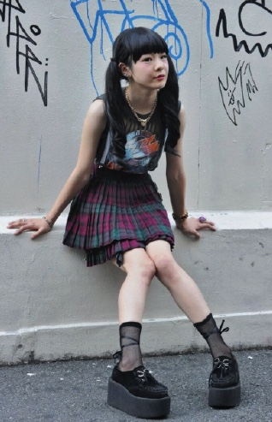
I’m not into clothes or fashion that much, but my parents think that clothes are important. They say that what you wear, the way you talk, and walk, identifies you as upper or lower class. My father always says “Fake it till you make it.” By that he means that if you dress and act like you are successful, some day you will be successful. The short version is, whenever I want or need clothes my parents give me the money.
I don’t have a whole lot of clothes, but the ones I do have are pretty good quality. My mother is picky about fabric. Sometimes, I’ll find a shirt or something that I like and she’ll examine it and say, “No, the fabric is cheap.” Oh well. Most of my clothes are kind of dressy casual, Polo shirts and jeans for school, and Nike running shoes to wear to school. In the winter I have this big NorthFace coat with so many pockets that I can’t find stuff when I need it. My favorite sports brand is Puma, and most of my exercise and lounging-around-the-house clothes are Puma, t-shirts and jogging pants, stuff like that.
I have one dress suit that I can wear year round, and I can always borrow a tie from my father. For a date, or social occasion, or when I must meet a professor, I’ll wear a white button-down dress shirt and some nice slacks. All dress shoes look the same to me but my father says you can tell a lot about a man by his shoes, and his haircut. I think he’s right.
So, there’s several sayings: “Clothes make the man. Your clothes are your wings. Dress for success.” My parents agree with that. They say that I’m a person in my own right, but I also represent them to the world, and they don’t want me dressing like a bum. (319 words)

• • •

I’m into clothes. To me clothes are an easy way that I can change my personality, or a way that I can show different moods. I dress according to my mood. When I’m feeling casual, I dress casual, usually shorts or jeans and designer t-shirts. My shorts are not too short, I think that’s a little bit tacky. Dressing sexy is OK, but not during the day or at school. Of course, I already have a boyfriend so I don’t have to dress like I’m looking for one. When I feel good about something, I’ll dress up a bit. I have a lot of skirts and tops, and a few weekday dresses. I like bright patterns and some of my skirts are two layers: you can see through the first one but not the second. I like to wear two- or three-inch heels because they make me look taller and slimmer , but by the evening my feet are hurting. I’m also into accessories. I have a lot of jewelry, necklaces, earrings, and rings. I also have several purses and handbags. I especially choose which bag to bring according to my mood. I like bags, and I’m hoping to go to Hong Kong and get a real Gucci bag this summer. That’s my plan. I’m not into shoes that much. I have some flats, some low-heeled casual shoes for everyday, and high heels for special occasions.
I spend a lot of time getting ready. Too much time. Sometimes I wish I could just throw anything on and go out the door. But fixing my hair and doing my makeup and picking out jewelry and matching tops, bottoms, belts, bags and shoes can take a good long while. I like to dress well for my boyfriend so that he can make his single friends jealous. The problem is, this gets me attention when I’m on my way to meet my boyfriend, and when guys look at me I think “Hey, I dressed this way for my boyfriend, not for you.” When I’m not in a good mood I wear dark colors and baggy clothes. Anyway, my clothes match my moods. The bad news is, my boyfriend says he can tell what mood I’ll be in by the way I’m dressed. Fine. (380 words)

