A14 Kim, Lee choi

Unit 1: My University Life

I guess you could say that my university life is half and half. Half school and half clubs. In high school I was an overachiever and studied all the time. My parents have big plans for me and it was important to them that I get into a good university. So, I spent my three high school years cramming. And after that I stayed out a year to cram some more. My father said that I can goof off a little during my freshmen year, but after that I must apply myself and focus again on good grades. Well, to be exact, my father has zero tolerance for anything lower than a B. I find that university is easier than high school because I’m taking courses that interest me. My main problem is that I have so many ideas, I cannot decide on one. For example, before picking a topic to write about, I procrastinate until the last minute. My father says I have to learn to prioritize and focus on what is important, and let the other stuff go.
I live off campus by myself in an apartment and it’s really convenient to live within walking distance of school. A few of my friends live in the dorm, but most of them commute about two hours to school every day. They would like to live in the dorm but to do that they must raise their GPA. Because I live near campus I can do all the club activities, even on the weekends. I belong to the guitar club and students from another university come here every Saturday to jam. I really like my guitar club, but the best guitarists are kind of cliquish and like to play only with each other. That’s fine by me, I enjoy hanging out with the wannabes. We have less talent, but more fun. So, I guess my freshmen year is my social year, and after that grades will be my top priority. Unless I magically get real good at guitar and get invited to join a major rock group. That would be cool. (351 words)

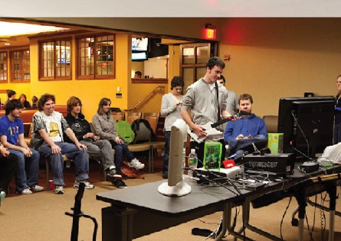
That’s me jamming solo.

