A12 Kim, Park lee

1 Sports & Summer

I like sports because I’m good at them, and it gives me a kind of reputation. Also, I enjoy teaching others how to play sports, especially kids. It would be wonderful if I could be a professional athlete of some kind, but if not, I think being a coach could be a good job. I used to be a couch potato and indoor person, but my father made me take little league baseball, and I found out that I was good at sports, and I like playing. I like the competition. Also, I’m a good sprinter, which helps in a lot of sports. My sports coach is a fitness freak and he’s really into sports. Fitness is like a product he’s trying to sell us. He’s muscular and he has killer abs, but he’s not a show off. Sports runs in his family, his brother and sister are also coaches. He runs the City Marathon every year, and he tries to get us to run the half marathon. He’s very limber, and he used to be on the national gymnastics team. He went to an Olympics, but I forgot where. His particular interest is finding the best sport for each student, which one we are best in. However, I think he gave up on my best friend. Coach told him, “I think your best sport is jogging.” Ha. Too funny. (230 words)

Vocabulary
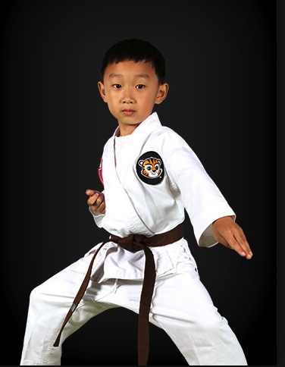
- athlete
- coach
- couch potato
- indoor person
- little league
- fitness freak
- into sports
- muscular
- killer abs
- runs in his family
- marathon
- half marathon
- limber
I took Taekwondo for four years.

